+

Entrance and antiphon © 2012-2014 Adam Bartlett, licensed under a Creative Commons www. Illuminarepublications.com

25th SUNDAY IN ORDINARY TIME YEAR A

ENTRANCE ANTIPHON

Psalm 78
Give ear, my people, to my teaching;
incline your ear to the words of my mouth.
I will open my mouth in a parable
and utter hidden lessons of the past.
The things we have heard and understood,
the things our fathers have told us,

these we will not hide from their children
but will tell them to the next generation:
the glories of the LORD and his might,
and the marvelous deeds he has done.

Glory be to the Father…

Kyrie, Gloria and Sanctus are found in theMusic Issue
the numbers are posted on hymn board : Chant Mass
LITURGY OF THE WORD
Responsorial Psalm in Today’s Missal.

ALLELUIA

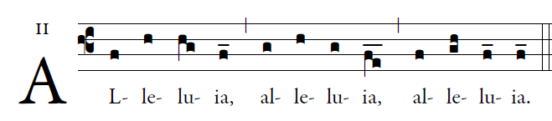
    Open our heartsm O Lord,
To listen to the words of your Son.

OFFERTORY HYMN
“ O God Beyond All Praising”

COMMUNION HYMN

Draw Near, and Take
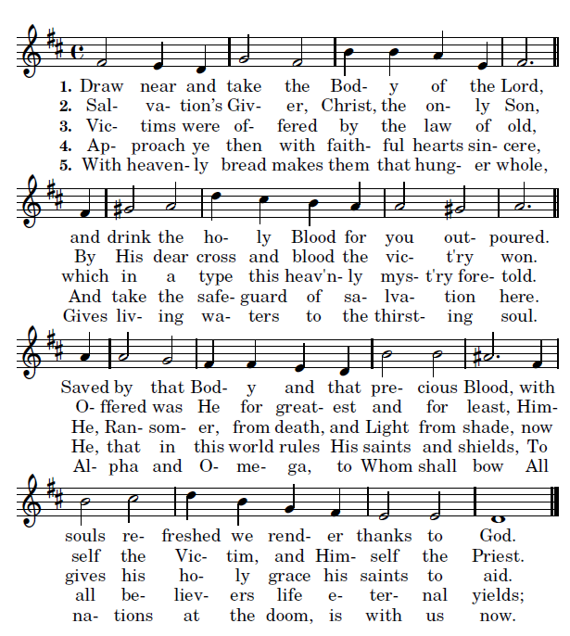
Of-
Tune: ALL SOULS (10 10 10 10) Text: Sancti Venite Christi Corpus Sumite

RECESSIONAL HYMN
“There’s a Wideness in God’s Mercy”

