COMMUNION HYMN
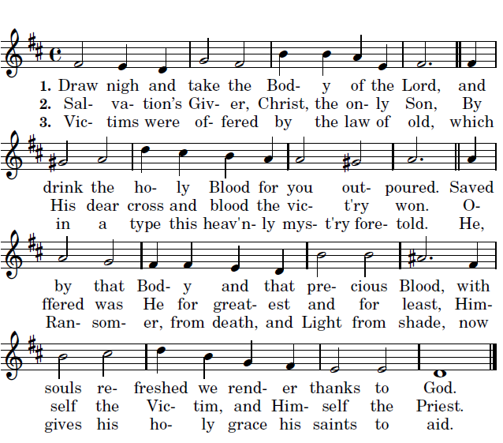
3.Approach ye then with faithful hearts sincere, And take the safeguard of salvation here. He, that in this world rules His saints and shields, To all believers life eternal yields;
4.With heavenly bread makes them that hunger whole, Gives living waters to the thirsting soul. Alpha and Omega, to Whom shall bow All nations at the doom, is with us now.

RECESSIONAL HYMN

“At the Name of Jesus”
Entrance and offertory antiphon s © 2012-2014 Adam Bartlett, licensed under a Creative Commons www. Illuminarepublications.com

25th SUNDAY IN ORDINARY TIME

ENTRANCE ANTIPHON

Psalm 78

Give ear, my people, to my teaching;
incline your ear to the words of my mouth.
²I will open my mouth in a parable
and utter hidden lessons of the past.
³The things we have heard and understood,
the things our fathers have told us,

⁴these we will not hide from their children
but will tell them to the next generation:
the glories of the LORD and his might,
and the marvelous deeds he has done.

Glory be to the Father…

LITURGY OF THE WORD

Ralph Bednarz 2015
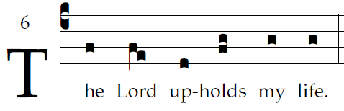

O God, by your name save me,
and by your might defend my cause.
O God, hear my prayer;
hearken to the words of my mouth.

For the haughty men have risen up against me,
the ruthless seek my life;
they set not God before their eyes.

Behold, God is my helper;
the Lord sustains my life.
Freely will I offer you sacrifice;
I will praise your name, O LORD, for its goodness.

ALLELUIA

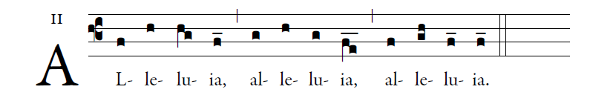

      God has called us with the Gospel
to possess the glory of our Lord Jesus Christ.

OFFERTORY ANTIPHON

I thank you, LORD, with all my heart;
you have heard the words of my mouth.
In the presence of the angels I praise you.
2 I bow down toward your holy temple.

I give thanks to your name
for your merciful love and your faithfulness.
You have exalted your name over all.
3 On the day I called, you answered me;
you increased the strength of my soul.

4 All earth’s kings shall thank you, O LORD,
when they hear the words of your mouth.
5 They shall sing of the ways of the LORD,
“How great is the glory of the LORD!”

6 The LORD is high, yet he looks on the lowly,
and the haughty he knows from afar.

