RECESSIONAL HYMN

MISERICORDIAS Music 2007, Henryk Jan Botar
permission requested

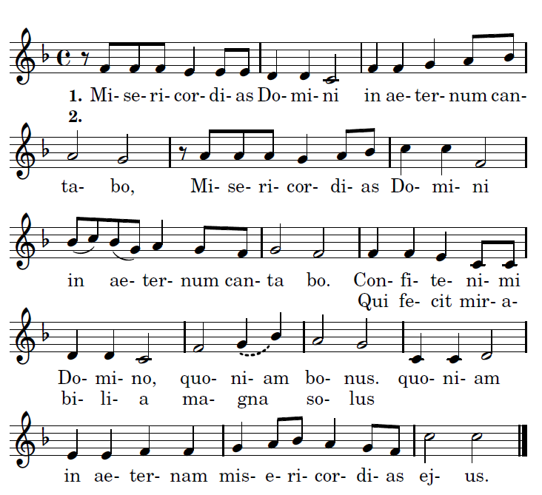

translation
I will sing of the mercies of the Lord for ever.

1. Praise the Lord, for he is good: for his mercy endures forever.

2. Who alone does great wonders: for his mercy endues forever.

24th Sunday of Ordinary Time YEAR C

HYMN OF THE HOLY YEAR OF MERCY

Translation: “Be merciful as the Father is merciful”
Refrain 1
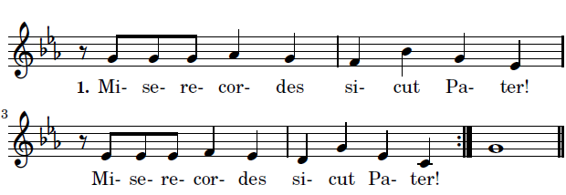
Cantor: Give thanks to the Father for he is good

Refrain 2
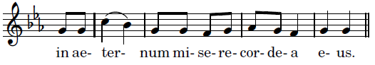
Cantor: He created the world with wisdom                    2
Cantor: He leads his pople thrughout history 2
Cantor: He pardons and welcomes his Children. 2 1

ALLELUIA illulminarepublication.com
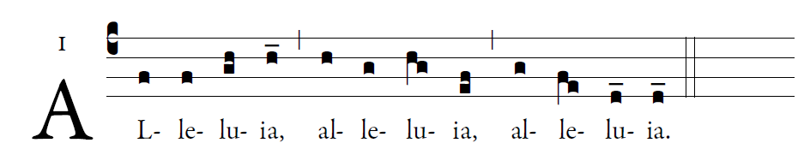
     GOD was reconciling the world to himself in Christ
and entrusting to us the message of reconciliation.

OFFERTORY HYMN
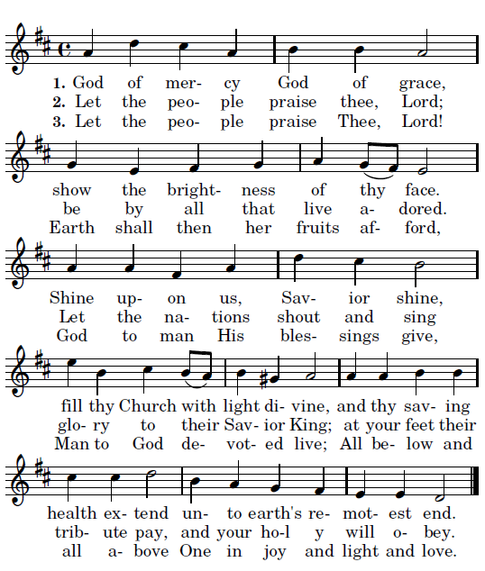

COMMUNION ANTIPHON
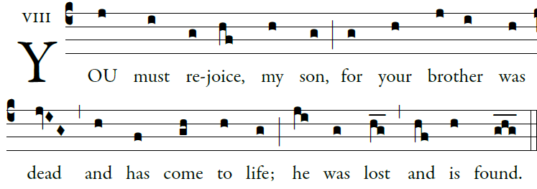
Illuminarepublications.com

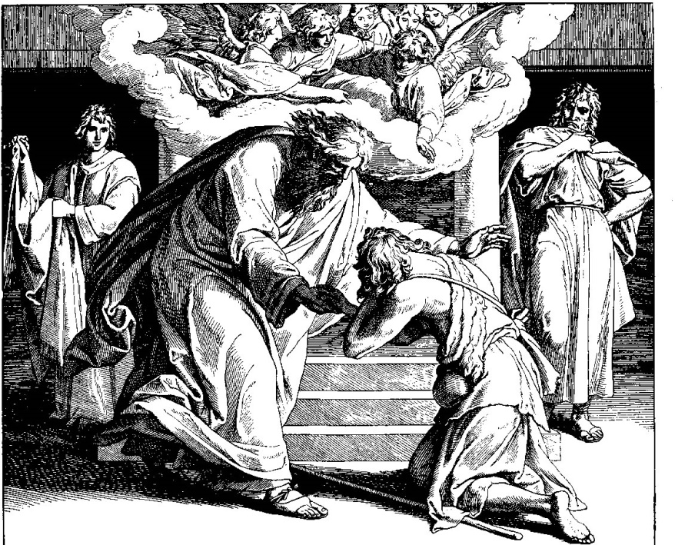
The father ran to his son.

Psalm 36
Your mercy, LORD, reaches to heaven,
your truth to the clouds.
Your justice is like God’s mountains;
like the great deep, your justice.
Both man and beast you save, O LORD.

How precious is your mercy, O God!
The children of men seek shelter
in the shadow of your wings.

They feast on the riches of your house;
you give them drink from the stream of your delight.
For with you is the fountain of life,
and in your light we see light.

