COMMUNION ANTIPHON
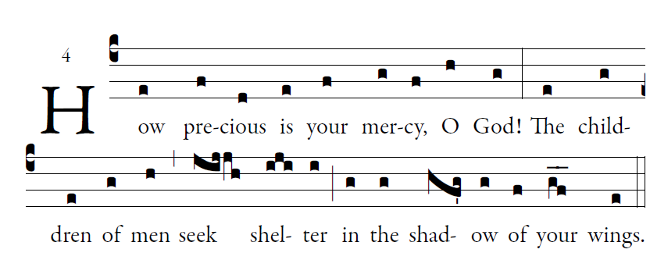
Fr Columba Kelly ©Saint Meinrad Archabbey
Your mercy, LORD, reaches to heaven,
your truth to the clouds.
⁷Your justice is like God’s mountains;
like the great deep, your justice.
Both man and beast you save, O LORD.

⁸How precious is your mercy, O God!
The children of men seek shelter
in the shadow of your wings.

⁹They feast on the riches of your house;
you give them drink from the stream of your delight.
¹⁰For with you is the fountain of life,
and in your light we see light.

Psalm 36
RECESSIONAL HYMN

“I am the Bread of Life ”
Beginning with “ Yes Lord , I believe…”

24th Sunday of Ordinary Time

ENTRANCE ANTIPHON

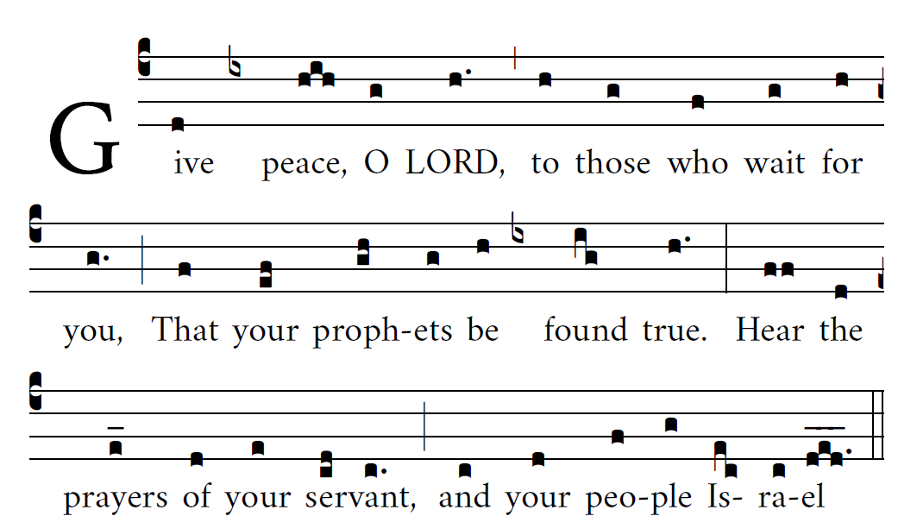
Bednarz 2018

I rejoiced when they said to me,
“Let us go to the house of the LORD.”
²And now our feet are standing
within your gates, O Jerusalem.

Jerusalem is built as a city
bonded as one together.
It is there that the tribes go up,
the tribes of the LORD.

For the sake of my family and friends,
let me say, “Peace upon you.”
For the sake of the house of the LORD, our God,
I will seek good things for you.

RESPONSORIAL PSALM

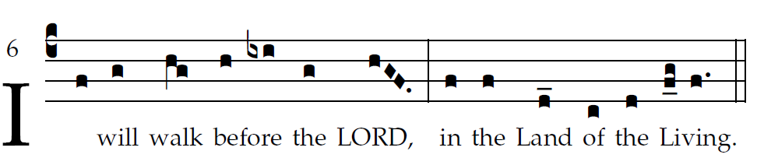
R Bednarz 2015

I love the LORD because he has heard
my voice in supplication,
Because he has inclined his ear to me
the day I called.
The cords of death encompassed me;
the snares of the netherworld seized upon me;
I fell into distress and sorrow,
And I called upon the name of the LORD,
“O LORD, save my life!”
Gracious is the LORD and just;
yes, our God is merciful.
The LORD keeps the little ones;
I was brought low, and he saved me.
For he has freed my soul from death,
my eyes from tears, my feet from stumbling.
I shall walk before the Lord
in the land of the living.

ALLELUIA

illulminarepublication.com
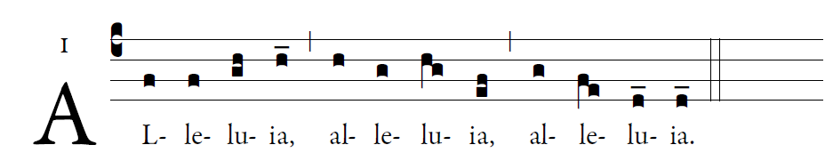

     May I never boast except in the cross of Our Lord | through which the word has been crucified to me and I to the world.

OFFERTORY HYMN

Soul of My Savior Anima Christi
