COMMUNION ANTIPHON

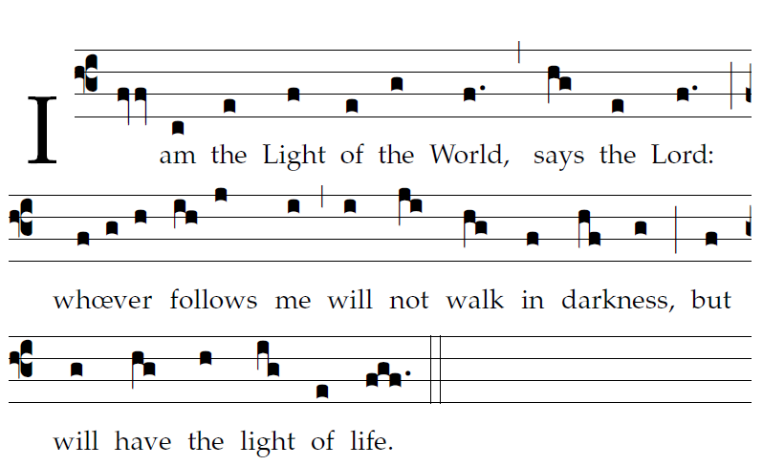 Fr Columba Kelly ©Saint Meinrad Archabbey
Your mercy, LORD, reaches to heaven,
your truth to the clouds.
Your justice is like God’s mountains;
like the great deep, your justice.

Both man and beast you save, O LORD.
How precious is your mercy, O God!
The children of men seek shelter
in the shadow of your wings.

They feast on the riches of your house;
you give them drink from the stream of your delight.
For with you is the fountain of life,
and in your light we see light.

RECESSIONAL HYMN
“Christ be Beside Me” Music Issue

23rd Sunday of Ordinary Time YEAR A

The ordinary of the Mass : Lord have mercy, Glory to God, Holy, Acclamation, Lamb of God: Masss of Pope Saint John Paul II.
Found on a separate program

ENTRANCE ANTIPHON
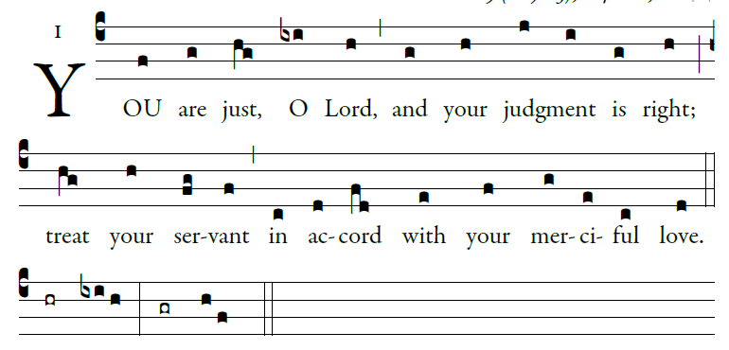

illulminarepublication.com
I call with all my heart;
LORD, answer me.
I will observe your statutes.
I call upon you; save me,
and I will keep your decrees.

I rise before dawn and cry for help;
I have hoped in your word.
My eyes awaken before dawn,
to ponder your promise.

In your mercy, hear my voice, O LORD;
give me life by your decrees.
Those who pursue me with malice draw near;
they are far from your law.

RESPONSORIAL PSALM
RB 2014
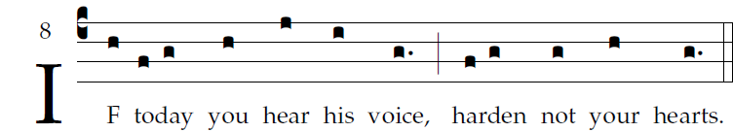

Come, let us sing joyfully to the LORD;
let us acclaim the rock of our salvation.
Let us come into his presence with thanksgiving;
let us joyfully sing psalms to him.

Come, let us bow down in worship;
let us kneel before the LORD who made us
For he is our God,
and we are the people he shepherds, the flock he guides.

Oh, that today you would hear his voice: [5]
"Harden not your hearts as at Mer-i-bah,
as in the day of Massah in the desert,
Where your fathers tempted me;
Though they had seen my work.

ALLELUIA
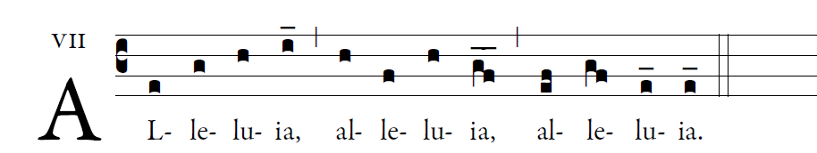
illulminarepublication.com

God was reconciling the world to himself in Christ
And entrusting to us the message of reconciliation

OFFERTORY: God of Mercy and Compassion

Au Sang Qu’un Dieu
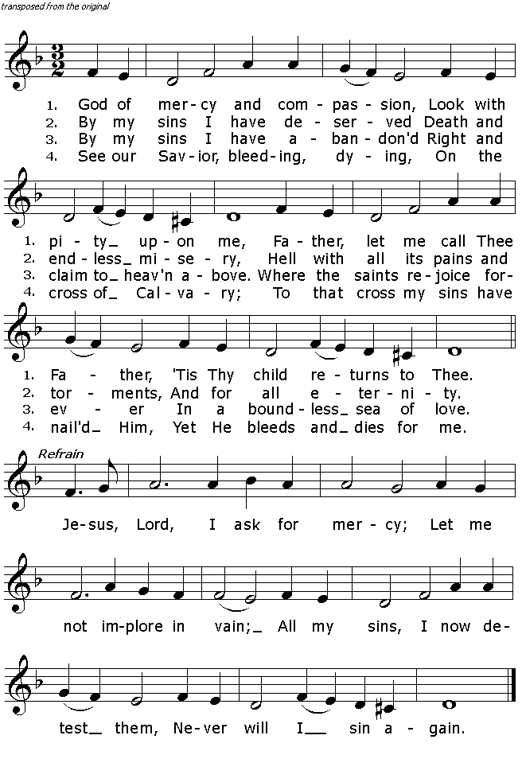 traditional French melody adaptation by G. B. Pergolesi 1736
Text: .E Vaughan C.SS.R.

