COMMUNION ANTIPHON

Fr Columba Kelly ©Saint Meinrad Archabbey

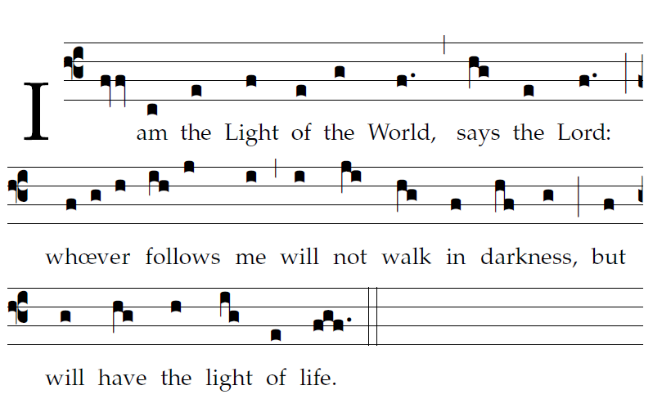

Your mercy, LORD, reaches to heaven,

your truth to the clouds.

7Your justice is like God’s mountains;

like the great deep, your justice.

Both man and beast you save, O LORD.

8How precious is your mercy, O God!

The children of men seek shelter

in the shadow of your wings.

9They feast on the riches of your house;

you give them drink from the stream of your delight.

10For with you is the fountain of life,

and in your light we see light.

RECESSIONAL HYMN

“Abide with Me” verses 2 and4

23rd Sunday of Ordinary Time

ENTRANCE ANTIPHON

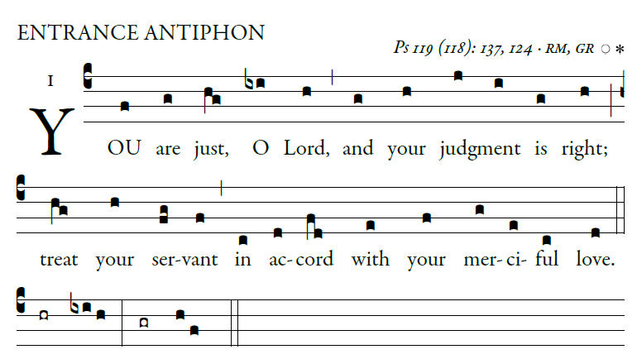

illulminarepublication.com

I call with all my heart;

LORD, answer me.

I will observe your statutes.

I call upon you; save me,

and I will keep your decrees.

I rise before dawn and cry for help;

I have hoped in your word.

My eyes awaken before dawn,

to ponder your promise.

In your mercy, hear my voice, O LORD;

give me life by your decrees.

Those who pursue me with malice draw near;

they are far from your law.

LITURGY OF THE WORD

RESPONSORIAL PSALM

illulminarepublication.com

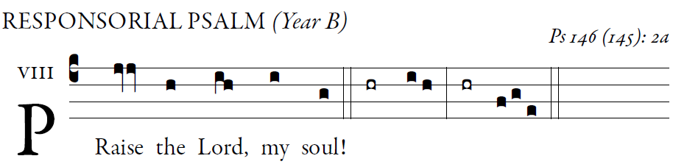

The God of Jacob keeps faith forever,  
secures justice for the oppressed,  
gives food to the hungry.  
The LORD sets captives free.

The LORD gives sight to the blind;  
the LORD raises up those who were bowed down.  
The LORD loves the just;  
the LORD protects strangers.

The fatherless and the widow the LORD sustains,  
but the way of the wicked he thwarts.  
The LORD shall reign forever;  
your God, O Zion, through all generations. Alleluia.

ALLELUIA

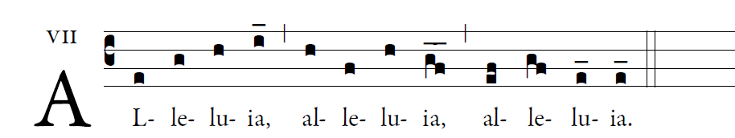

illulminarepublication.com

Jesus proclaimed the Gospel of the kingdom

and cured every disease among the peope.

OFFERTORY

“When Morning Guilds the Skies ”

1 When morning gilds the sky,   
our hearts awaking cry:   
May Jesus Christ be praised!   
in all our work and prayer   
we ask his loving care:   
May Jesus Christ be praised!

2 To God, the Word on high,   
the hosts of angels cry:   
May Jesus Christ be praised!   
Let mortals too upraise   
their voices in hymns of praise:   
May Jesus Christ be praised!

3 Let earth's wide circle round   
in joyful notes resound:   
May Jesus Christ be praised!   
Let air and sea and sky   
from depth to height reply:   
May Jesus Christ be praised!