LAMB OF GOD
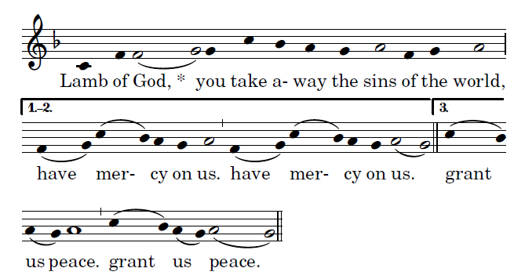
Ordinary of the Mass by Richard Clark, Used with permisision

COMMUNION ANTIPHON
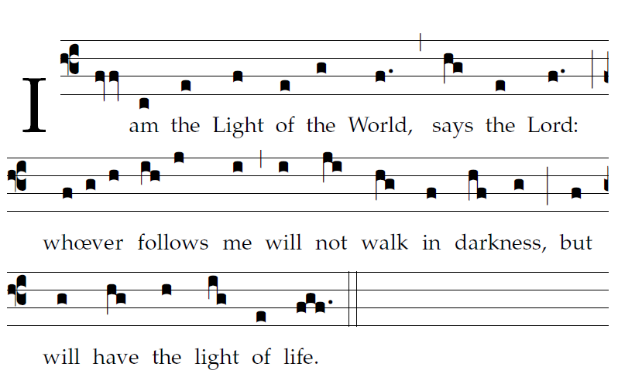 Fr Columba Kelly ©Saint Meinrad Archabbey
Your mercy, LORD, reaches to heaven,
your truth to the clouds.
Your justice is like God’s mountains;
like the great deep, your justice.

RECESSIONAL HYMN: “ Lift High the Cross”

23nd SUNDAY in ORDINARY TIME

ENTRANCE ANTIPHON

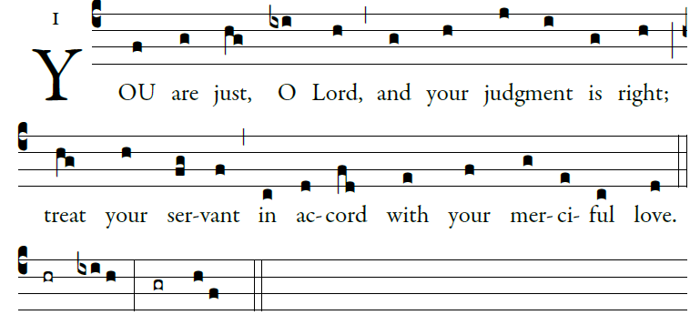
I call with all my heart;
LORD, answer me.
I will observe your statutes.
I call upon you; save me,
and I will keep your decrees.

LORD HAVE MERCY

GLORIA

ALLELUIA
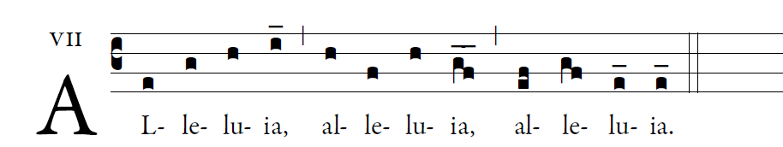
Let your face shine upon your servant;
and teach me your laws.

OFFERTORY “ Let All Mortal Flesh Keep Silence”

SANCTUS
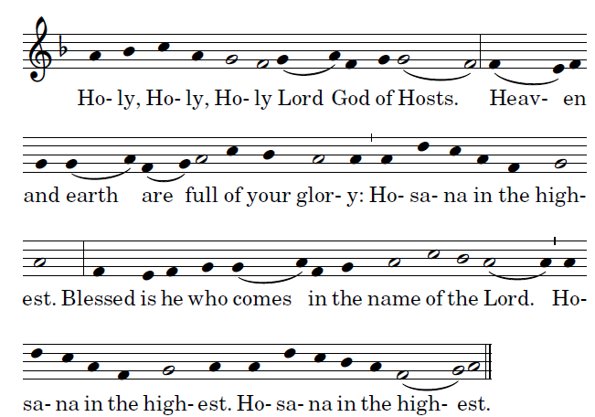
MEMORIAL ACCLAMATION 