^{©Illuminarepublications.com}
PSALM 86 (85) [5]1 ,2 4, 6, 7 8
O Lord you are good and forgiving
Full of mercy to all who call to you.
Turn your ear, O LORD, and answer me,
For I am poor and needy

Preserve my soul for I am faithful;
save the servant who trusts in you, my God.
Gladden the soul of your servant,
For I lift up my soul to You.

Give ear O LORD, to our prayer,
And attend to my voice in supplication.
_________________________________

RESPONSORIAL PSALM
RB 2014,2017,2023
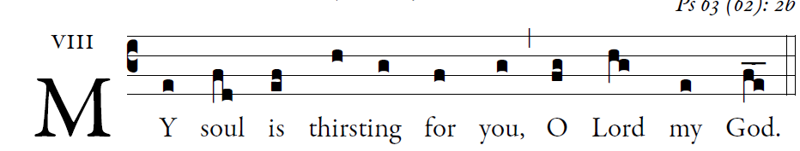

O God, you are my God whom I seek;
for you my flesh pines and my soul thirsts
like the earth,
parched, lifeless and without water.
Thus have I gazed toward you in the sanctuary
to see your power and your glory,
For your kindness is a greater good than life;
my lips shall glorify you.
Thus will I bless you while I live;
lifting up my hands, I will call up on your name.
As with the riches of a banquet shall my soul be satisfied,
and with exultant lips my mouth shall praise you.

You are my help,
and in the shadow of your wings I shout for joy.
My soul clings fast to you;
your right hand upholds me.

Murray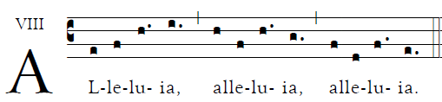

___________________

OFFERTORY: “ Lift High the Cross “717 MI

COMMUNION ANTIPHON:
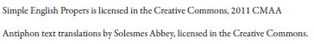
I will bless the lord at all times;
Praise of Him always in my mouth.
Look toward him and be radiant;
Let your faces not be abashed.
The lowly one called; the LORD heard,
And rescued him from all his distress.

Turn aside from evil and do good.
Seek after peace, and pursue it.
The LORD turns his eyes to the just,
And his ears are open to their cry.
The LORD turns his face against the wicked
to destroy their remembrance from the earth.

When the just cry out the LORD hears,
and rescues them in all their distress.
The LORD is close to the brokenhearted;
those whose spirit is crushed he will save.

Many are the trials of the just man…
_____________________
RECESSIONAL Abide With Me #641 MI

22nd Sunday
YEAR A

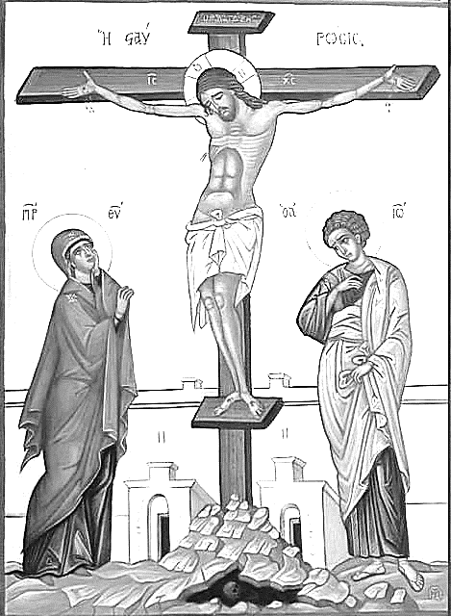

“Whoever wishes to come after me must deny himself,
Take up his cross, and follow me” Mathew 16:25

