MEMEMORIAL ACCLAMATION
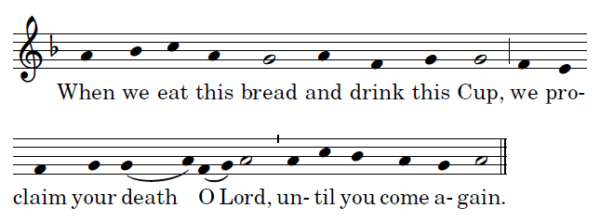

LAMB OF GOD
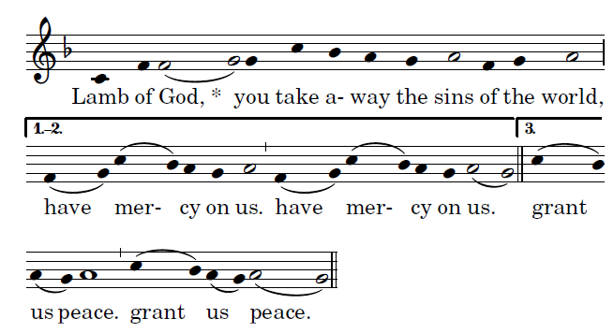
Ordinary of the Mass by Richard Clark, Used with permisision

COMMUNION ANTIPHON
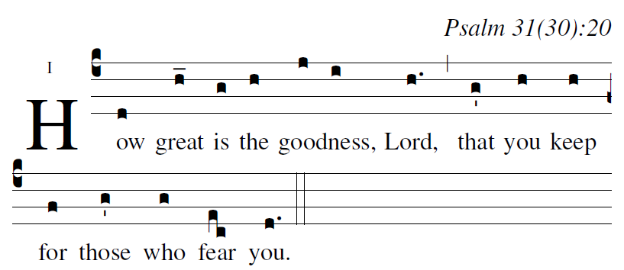
Ralph Bednarz 2014

RECESSIONAL HYMN: “ Christ, Be Our Light”

22nd SUNDAY

ENTRANCE ANTIPHON
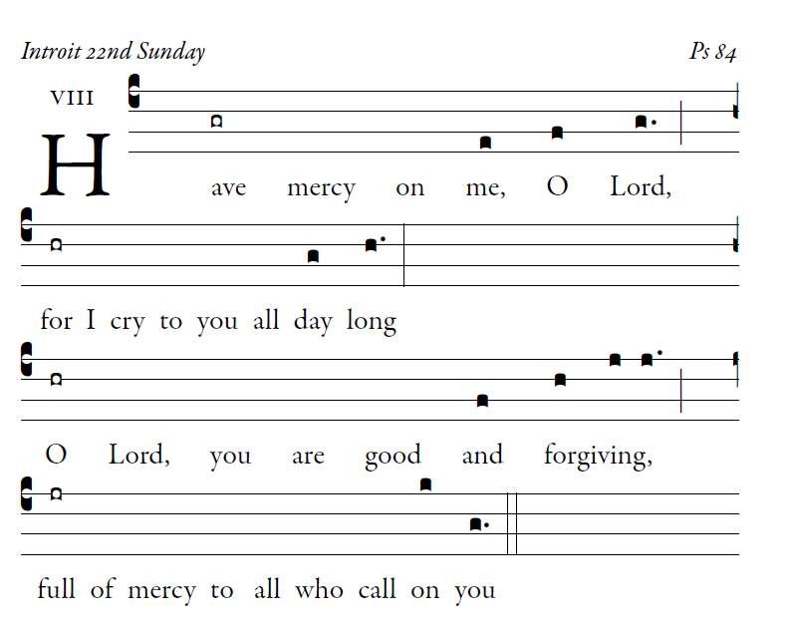

How lovely is your dwelling place,
O Lord of hosts.
my soul is longing and yearning
for the courts of the Lord.

LORD HAVE MERCY
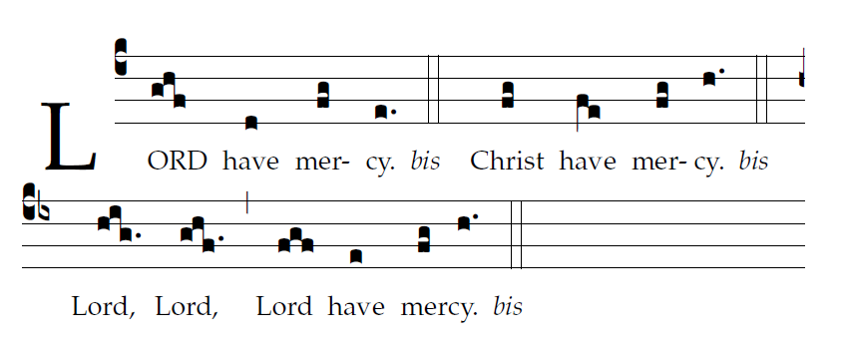

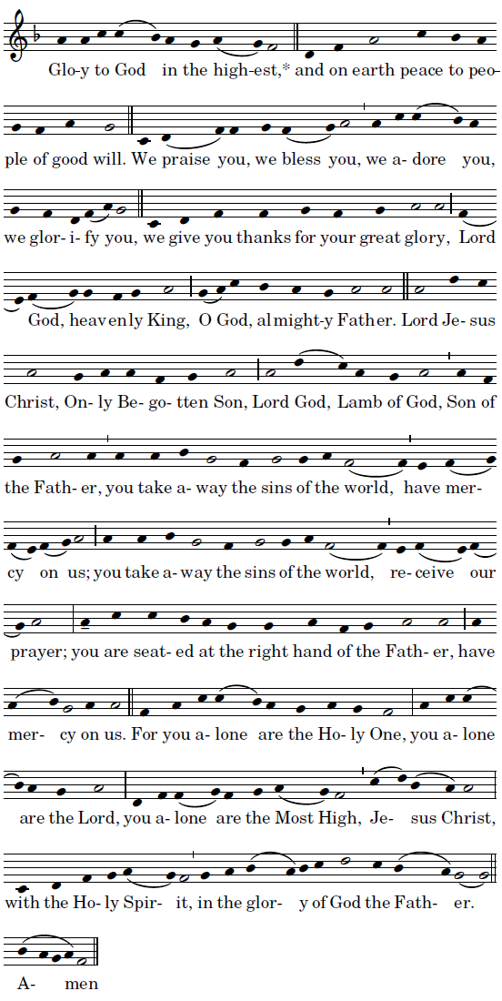

LITURGY OF THE WORD
from Todays Missal
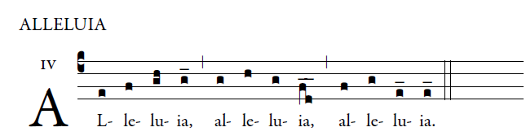

OFFERTORY “ Humbly, Lord, We Worship You”

HOLY
