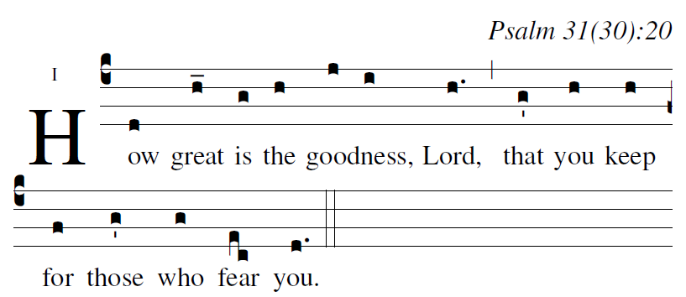
R.Bednarz 2014

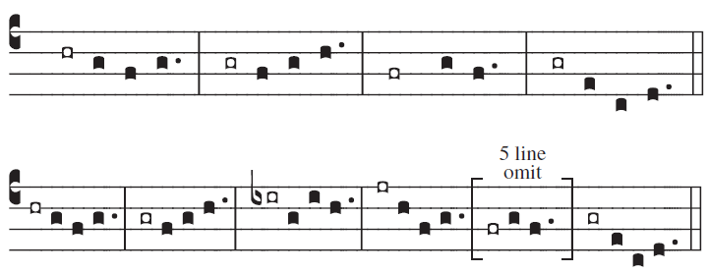

Psalm 31
²In you, O LORD, I take refuge.
Let me never be put to shame.
In your justice, set me free;
³incline your ear to me, and speedily rescue me.
Be a rock of refuge for me,
a mighty stronghold to save me.
⁴For you are my rock, my stronghold!
Lead me, guide me, for the sake of your name.

⁵Release me from the snare they have hidden, [6]
for you indeed are my refuge.
⁶Into your hands I commend my spirit.
You will redeem me, O LORD, O faithful God.
⁷You detest those who serve empty idols.
As for me, I trust in the LORD.

⁸Let me be glad and rejoice in your mercy, [5]
for you who have seen my affliction
and taken heed of my soul’s distress,
⁹have not left me in the hands of the enemy,
but set my feet at large.

¹⁷Let your face shine on your servant. [6]
Save me in your merciful love.
¹⁸Let me not be put to shame, O LORD,
for I call on you;
let the wicked be shamed!
Let them be silenced in the grave!

²⁰How great is the goodness, LORD,
that you keep for those who fear you,
that you show to those who trust you
in the sight of the children of men.

²¹You hide them in the shelter of your presence,
secure from human scheming;
you keep them safe within your tent
from disputing tongues.

²²Blest be the LORD for he has wondrously shown me
his merciful love in a fortified city!

²⁴Love the LORD, all you his saints. [5]
The LORD guards the faithful.
But the LORD will repay to the full
the one who acts with pride.
²⁵Be strong, let your heart take courage,
all who hope in the LORD.

user-notes: ;
commentary: Psalm 31(30):20 ;
annotation: I ;
centering-scheme: english;
%fontsize: 12;
%spacing: vichi;
%font: times;
%width: 4;
%height: 11;
%%
(c4)How(d) great(h_) is(g) the(h) {good}ness,(j/ i) Lord,(h.) (,) that(g') you(h) keep(h) for(f) those(g') who(g) fear(ec) you.(d.) (::)

