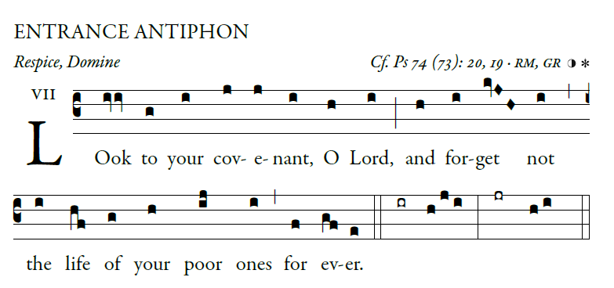
Illuminarepublications.com

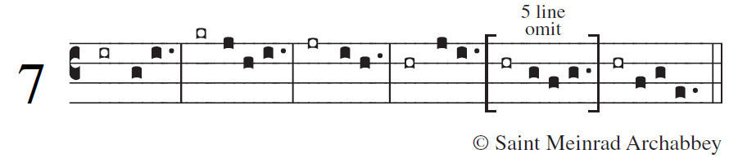

Why, O God, have you cast us off forever?
Why does your anger blaze at the sheep of your pasture?
²Remember your flock which you claimed long ago,
the tribe you redeemed to be your own possession,

Turn your steps to these places that are utterly ruined!
The enemy has laid waste the whole of the holy place.
⁴Your foes have made uproar in the midst of your assembly;
they have set up their emblems as tokens there.

Arise, O God, and defend your cause!
Remember how the senseless revile you all the day.
²³Do not forget the clamor of your foes,
the unceasing uproar of those who defy you.

