RECESSIONAL HYMN

Jesus, my Lord, my God, my all!
How can I love Thee as I ought?
And how revere this wondrous gift,
So far surpassing hope or thought?
Refrain:
Sweet Sacrament, we Thee adore!
Oh, make us love Thee more and more.
Oh, make us love Thee more and more.
Thy Body, Soul and Godhead, all!
O mystery of love divine!
I cannot compass all I have,
For all Thou hast and art is mine!

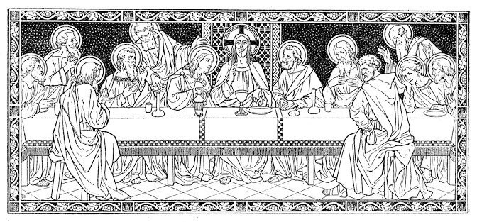

18th SUNDAY in ORDINARY TIME _{(year B)}
Lord Have Mercy, Glory to god, Holy and Lamb of God
from the Missa Simplex booklet

ENTRANCE ANTIPHON
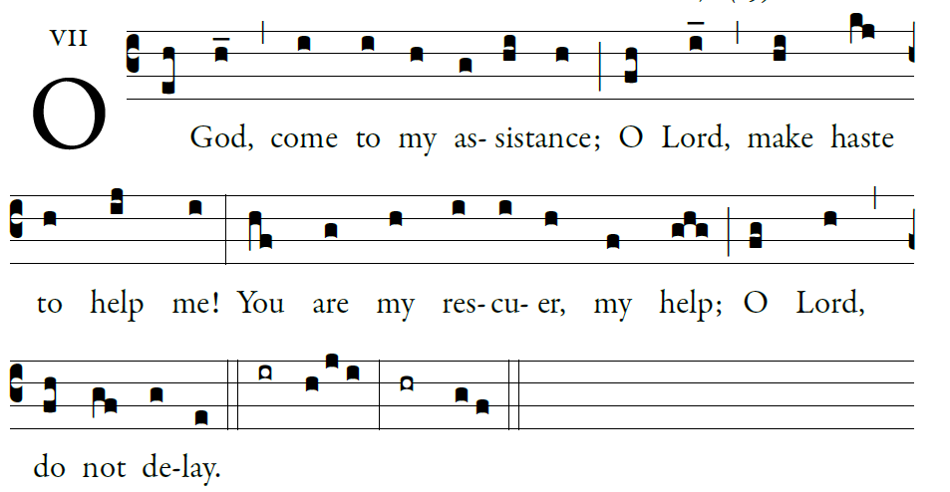

Illuminarepublications.com
O let them turn back in confusion,
who delight in my harm;
let them retreat, covered with shame,
who jeer at me and mock
.
⁵O let there be rejoicing and gladness
for all who seek you.
Let them say forever, “God is great,”
who love your saving help.

As for me, wretched and poor,
hasten to me, O God.
You are my rescuer, my help;
O LORD, do not delay

RESPONSORIAL PSALM
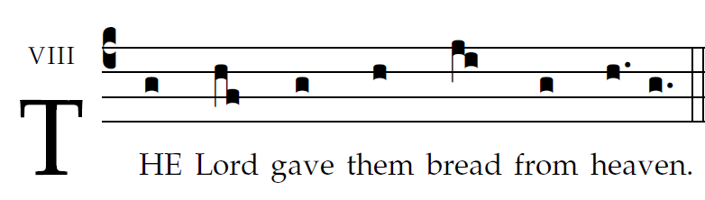

What we have heard and know,
and what our fathers have declared to us,
We will declare to the generation to come
the glorious deeds of the LORD and his strength
and the wonders that he wrought.
He commanded the skies above
and opened the doors of heaven;
he rained manna upon them for food
and gave them heavenly bread.
Man ate the bread of angels,
food he sent them in abundance.
And he brought them to his holy land,
to the mountains his right hand had won.

GOSPEL ALLELUIA

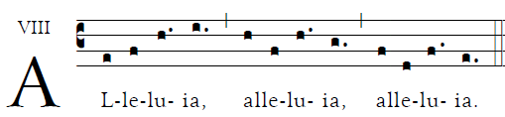

One does not live on bread alone,
but on every word that comes from the mouth of God.

OFFERTROY HYMN:
“ I am the Bread of Life”

COMMUNION ANTIPHON
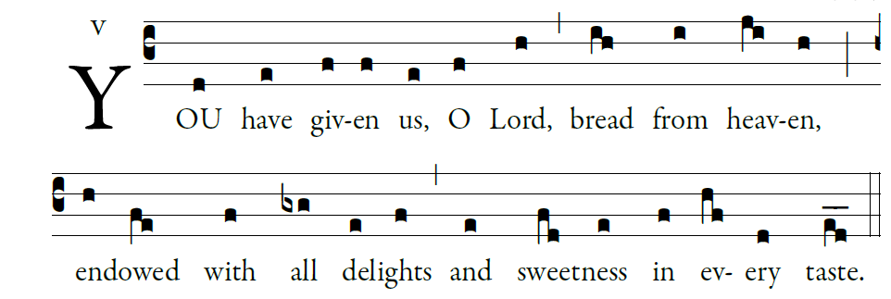
Antiphon : Illuminarepublications.com

¹Give ear, my people, to my teaching;
incline your ear to the words of my mouth.
²I will open my mouth in a parable
and utter hidden lessons of the past.

³The things we have heard and understood,
the things our fathers have told us,
⁴these we will not hide from their children
but will tell them to the next generation:
the glories of the LORD and his might,
and the marvelous deeds he has done.

Yet he commanded the clouds above,
and opened the gates of heaven.
²⁴He rained down manna to eat,
and gave them bread from heaven.

²⁵Man ate the bread of angels.
He sent them abundance of food;
^{Psalm 78}

