RECESSIONAL HYMN

JESUS MY LORD MY GOD MY ALL

Jesus My Lord My God My All
Thy Body, Soul - and God - head, all!
O mystery of love divine!
I cannot compass all I have,
For all Thou hast and art is mine!
Refrain:
Sweet Sacrament, we Thee adore!
Oh, make us love Thee more and more.
Oh, make us love Thee more and more.
Sound, then, His prais - es high - er still,
And come, ye angels, to our aid;
For this is God, the very God
Who hath both men and angels made

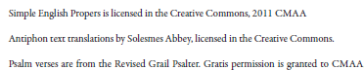

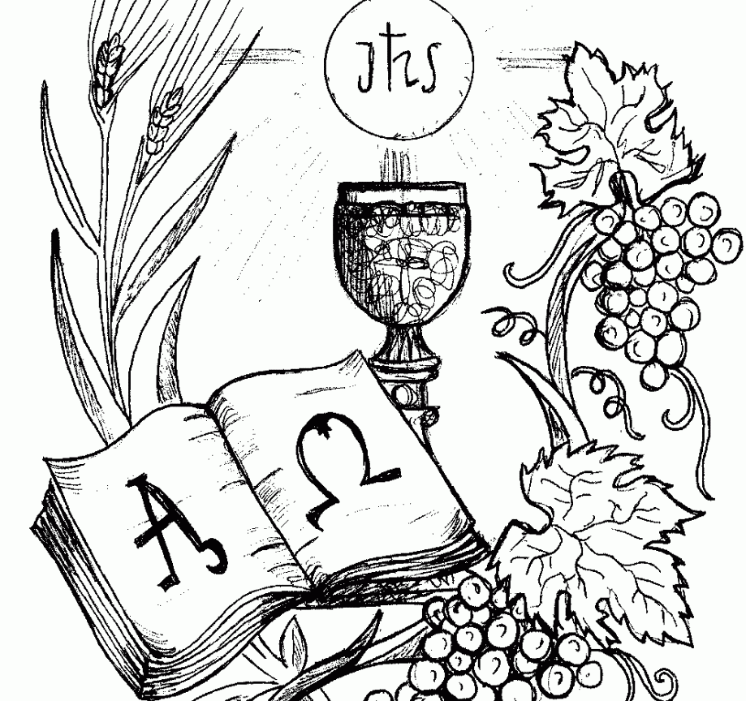
17 ^{th} Sunday
in Ordinary Time YEAR B

ENTRANCE ANTIPHON

Let God arise; let his foes be scattered.
Let those who hate him flee from his presence.
As smoke is driven away, so drive them away;
like wax that melts before the fire,

so the wicked shall perish at the presence of God.
But the just shall rejoice at the presence of God;
they shall exult with glad rejoicing.
O sing to God; make music to his name.

Glory be to the Father … 

RESPONSORIAL PSALM and ALLELUIA
from Todays Missal

OFFERTORY HYMN
“Godhead Here in Hiding”

COMMUNION ANTIPHON and HYMN
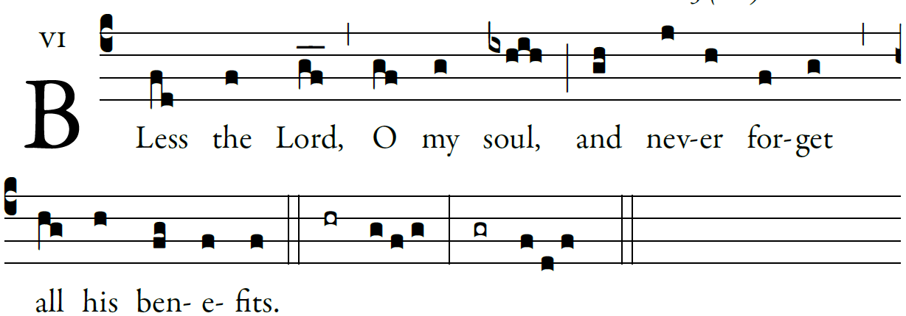

©Illuminarepublications.com

Bless the LORD, O my soul,
and all within me, his holy name.
Bless the LORD, O my soul,
and never forget all his benefits.

It is the Lord who forgives all your sins,
who heals every one of your ills,
who redeems your life from the grave,
who crowns you with mercy and compassion,
who fills your life with good things,
renewing your youth like an eagle’s.

The LORD does just deeds,
gives full justice to all who are oppressed.
He made known his ways to Moses,
and his deeds to the children of Israel.

COMMUNION HYMN

TANTUM ERGO Th, DuBois
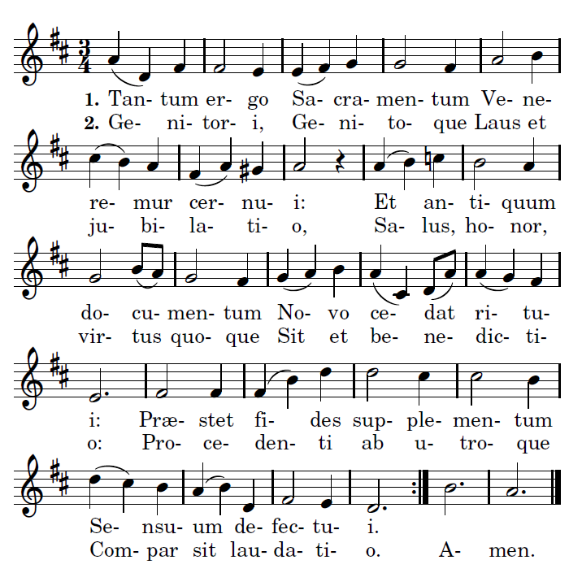
To the everlasting Father,
And the Son Who reigns on high
With the Holy Spirit proceeding
Forth from each eternally,
Be salvation, honor blessing,
Might and endless majesty. Amen.

Down in adoration falling,
Lo! the sacred Host we hail,
Lo! o'er ancient forms departing
Newer rites of grace prevail;
Faith for all defects supplying,
Where the feeble senses fail.

