RECESSIONAL HYMN

IMMACULATE MARY

The Immaculate Conception: Patroness of the United States
Immaculate Mary,
Our hearts are on fire,
that title so wondrous
fills all our desire.
Ave, ave, ave Maria!
Ave, ave, ave Maria!
We pray for our mother
the church upon earth,
and bless, sweetest lady,
the land of our birth.
Ave, ave, ave Maria!
Ave, ave, ave Maria!

proper antiphon from The Simple English Propers
Adam Bartlett ©CMAACreative commons , for free use

14th Sunday in Ordinary Time

ENTRANCE ANTIPHON

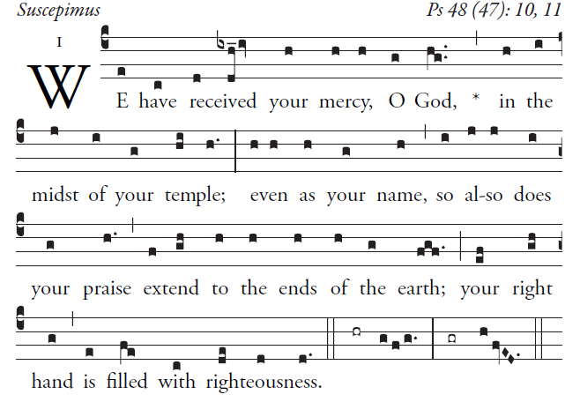

Great is the LORD and highly to be praised
in the city of our God.
His holy mountain rises in beauty,
the joy of all the earth.
Mount Sion, in the heart of the North,
the city of the Mighty King!
God, in the midst of its citadels,
has shown himself its stronghold.

RESPONSORIAL PSALM

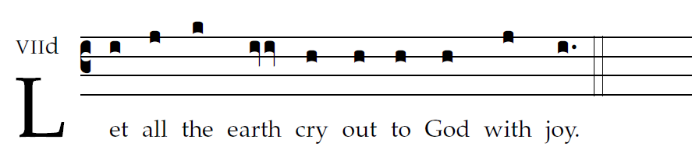

Shout joyfully to God, all the earth,
sing praise to the glory of his name;
proclaim his glorious praise.
Say to God, "How tremendous are your deeds!"
"Let all on earth worship and sing praise to you,
sing praise to your name!"
Come and see the works of God,
his tremendous deeds among the children of Adam.
He has changed the sea into dry land;
through the river they passed on foot;
therefore let us rejoice in him.
He rules by his might forever.
Hear now, all you who fear God, while I declare
what he has done for me.
Blessed be God who refused me not
my prayer or his kindness!

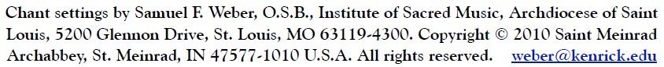

OFFERTORY ANTIPHON

I love you, LORD, my strength;
O LORD, my rock, my fortress, my savior;
my God, my rock where I take refuge;
my shield, my saving strength, my stronghold.
cry out, “Praised be the LORD!”
and see, I am saved from my foes.

COMMUNION ANTIPHON

