I will bless the LORD at all times;
praise of him is always in my mouth.
³In the LORD my soul shall make its boast;
the humble shall hear and be glad.

⁴Glorify the LORD with me;
together let us praise his name.
⁵I sought the LORD, and he answered me;
from all my terrors he set me free.

⁶Look toward him and be radiant;
let your faces not be abashed.
⁷This lowly one called; the LORD heard,
and rescued him from all his distress.

RECESSIONAL HYMN “ Christ be Beside Me”

proper antiphon from The Simple English Propers
Adam Bartlett CMAA

14th Sunday in Ordinary Time year B

ENTRANCE ANTIPHON

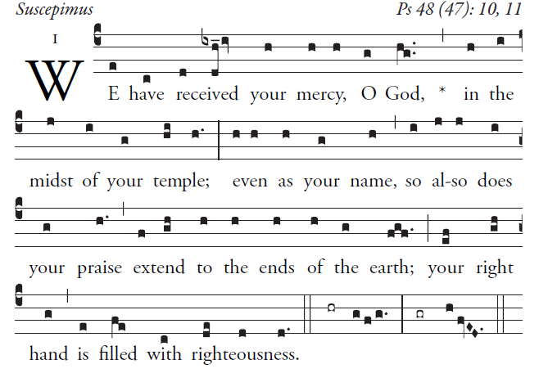

Great is the LORD and highly to be praised
in the city of our God.
³His holy mountain rises in beauty,
the joy of all the earth.
Mount Sion, in the heart of the North,
the city of the Mighty King!
⁴God, in the midst of its citadels,
has shown himself its stronghold.

illluminarepublications.com

To you I lift up my eyes
who are enthroned in heaven —
As the eyes of servants
are on the hands of their masters.
As the eyes of a maid
are on the hands of her mistress,
So are our eyes on the LORD, our God,
till he have pity on us.
Have pity on us, O LORD, have pity on us,
for we are more than sated with contempt;
our souls are more than sated
with the mockery of the arrogant,
with the contempt of the proud.

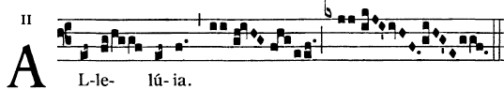

The Spirit of the Lord is upon me
for he sent me to bring glad tidings to the poor.

OFFERTORY

I love you, LORD, my strength;
O LORD, my rock, my fortress, my savior;
my God, my rock where I take refuge;
my shield, my saving strength, my stronghold.
I cry out, “Praised be the LORD!”
and see, I am saved from my foes.

The waves of death rose about me;
the torrents of destruction assailed me;
the snares of the grave surrounded me;
the traps of death confronted me.

