⁹He will not always find fault;
⁶The LORD does just deeds,
gives full justice to all who are oppressed.
⁷He made known his ways to Moses,
and his deeds to the children of Israel.

⁸The LORD is compassionate and gracious,
slow to anger and rich in mercy.

RECESSIONAL HYMN:

“Christ Before Us”

,

13th Sunday in Ordinary Time YEAR B

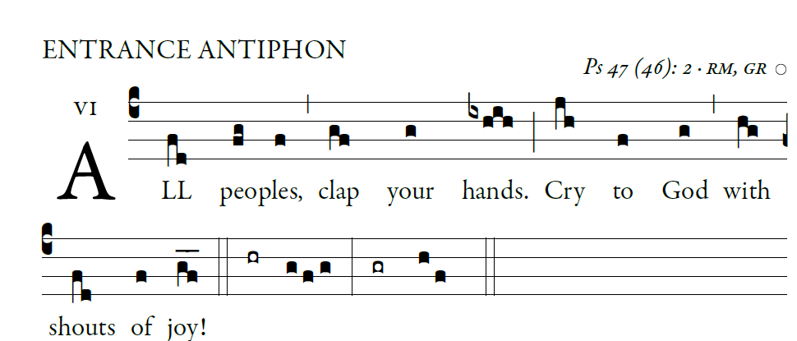
ENTRANCE ANTIPHON

Psalm 28 (27)

For the LORD, the Most High, is awesome,
the great king over all the earth.
He humbles peoples under us
and nations under our feet.

Our heritage he chose for us,
the pride of Jacob whom he loves.
God goes up with shouts of joy.
The LORD goes up with trumpet blast.

Sing praise for God; sing praise!
Sing praise to our king; sing praise!
God is king of all the earth.
Sing praise with all your skill.
God reigns over the nations.
God sits upon his holy throne.

Kyrie and Gloria (in Todays Missal, with in the order of the Mass)

RESPONSORIAL PSALM (year B)

I will extol you, O LORD, for you drew me clear
and did not let my enemies rejoice over me.
O LORD, you brought me up from the netherworld;
you preserved me from among those going down into the pit.

Sing praise to the LORD, you his faithful ones,
and give thanks to his holy name.
For his anger lasts but a moment;
a lifetime, his good will.
At nightfall, weeping enters in,
but with the dawn, rejoicing.

Hear, O LORD, and have pity on me;
O LORD, be my helper.
You changed my mourning into dancing;
O LORD, my God, forever will I give you thanks.

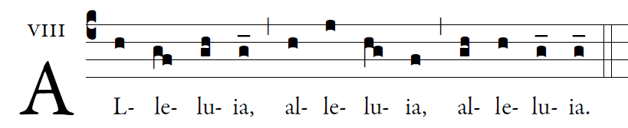

Our Savior Jesus Christ destroyed death
and brought us life through the gospel.

OFFERTORY HYMN:

Praise My Soul the King of Heaven

Holy & Lamb of God: Found in Today’s Missal
within the order of the Mass text.

COMMUNION ANTIPHON

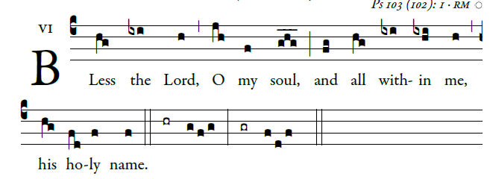

Bless the LORD, O my soul,
and all within me, his holy name.
²Bless the LORD, O my soul,
and never forget all his benefits.

³It is the LORD who forgives all your sins,
who heals every one of your ills,
⁴who redeems your life from the grave,
who crowns you with mercy and compassion,
⁵who fills your life with good things,
renewing your youth like an eagle’s.

