COMMUNION ANTIPHON ©Saint MeinradArchabbey.

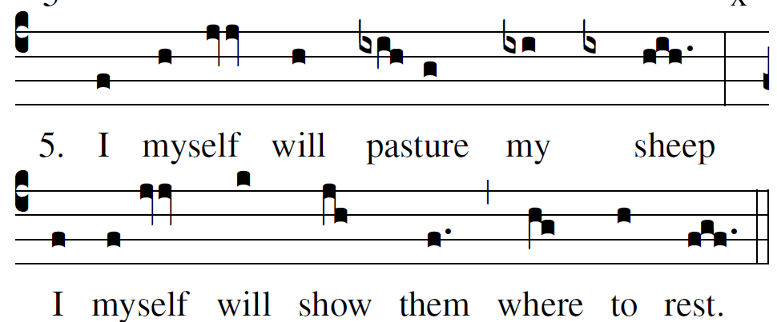

RECESSIONAL HYMN: “ O SACRED HEART”
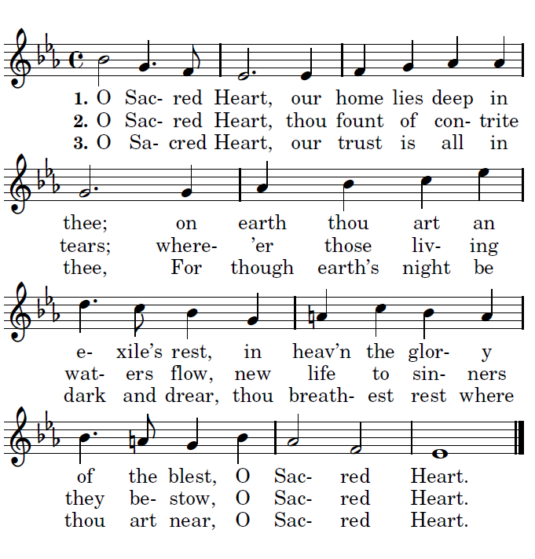

TWELFTH SUNDAY IN ORDINARY TIME
year C

ENTRANCE ANTIPHON

To you, O LORD, I call;
my rock, be not deaf to me.
I shall go down to those in the pit,
if you are silent to me.

Hear the voice of my pleading
as I call to you for help,
as I raise my hands
toward your holy place.

RESPONSORIAL PSALM

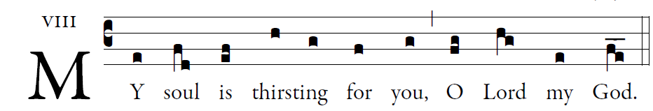
©Illuminarepublications.com

O God, you are my God whom I seek;
for you my flesh pines and my soul thirsts
like the earth, parched, lifeless and without water.
Thus have I gazed toward you in the sanctuary
to see your power and your glory,
For your kindness is a greater good than life;
my lips shall glorify you.
Thus will I bless you while I live;
lifting up my hands, I will call upon your name.
As with the riches of a banquet shall my soul be satisfied,
and with exultant lips my mouth shall praise you.
.
You are my help,
and in the shadow of your wings I shout for joy.
My soul clings fast to you;
your right hand upholds me.

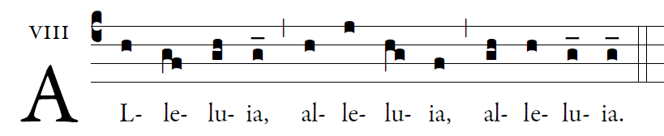

My Sheep hear my voice, says the Lord;
I know them, and they follow me.

OFFERTORY

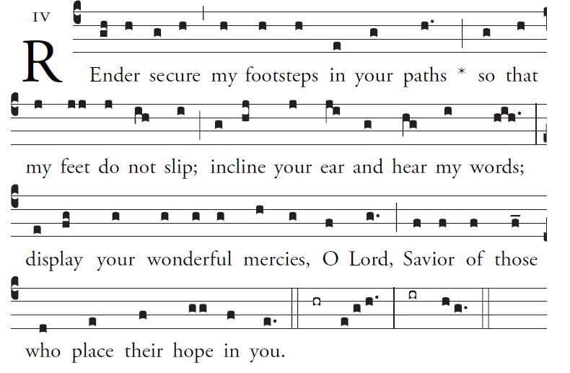

O LORD, hear a cause that is just;
pay heed to my cry.
Turn your ear to my prayer:
no deceit is on my lips.
From you may my justice come forth.
Your eyes discern what is upright.

Search my heart and visit me by night.
Test me by fire, and you will find no wrong in me.
My mouth does not transgress as others do;
on account of the words of your lips,
I closely watched the paths of the violent.

