COMMUNION HYMN

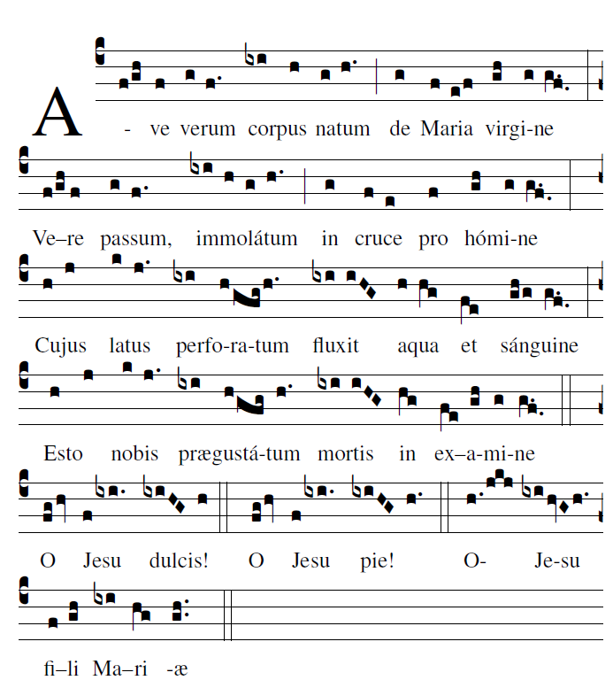

Mass of St John Paul II ©Richard Clark
__
RECESSIONAL HYMN: “Christ be Our Light ”
Mass of St John Paul II ©Richard Clark
__

THIRD SUNDAY
in ORDINARY TIME
YEAR B

The Lord Have Mercy, Glory to God, Holy and Lamb of God are
found on the
TODAY”S MISSAL MUSIC ISSUE
Chant Mass 844

ENTRANCE ANTIPHON:
SIMPLE ENGLISH PROPERS
ADAM BARTLETT © CMAA.COM

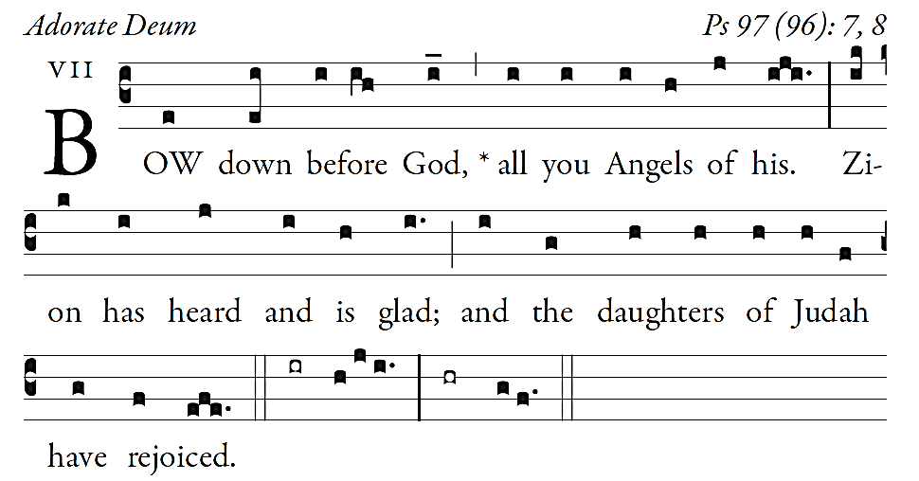

The heavens declare the glory of God,
and the firmament proclaims the work of his hands.
Day unto day conveys the message,
and night unto night imparts the knowledge.

No speech, no word, whose voice goes unheeded;
their sound goes forth through all the earth,
their message to the utmost bounds of the world.

There he has placed a tent for the sun;
it comes forth like a bridegroom coming from his tent,
rejoices like a champion to run his course.

OFFERTORY HYMN: “Of the Fathers Love Begotten”

COMMUNION ANTIPHON:
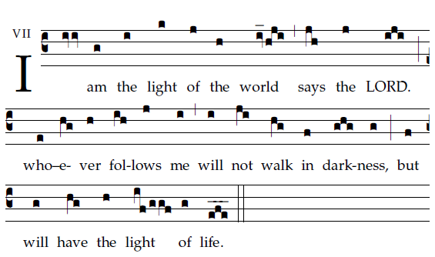
Fr, Columba Kelly © St. Meinrad Archabbey

Your mercy, LORD, reaches to heaven,
your truth to the clouds.
Your justice is like God’s mountains;
like the great deep, your justice.

Both man and beast you save, O LORD.
How precious is your mercy, O God!
The children of men seek shelter
in the shadow of your wings.

They feast on the riches of your house;
you give them drink from the stream of your delight.
¹For with you is the fountain of life,
and in your light we see light.

¹Maintain your mercy for those who know you,
your saving justice to upright hearts.
¹Let the foot of the proud not tread on me
nor the hand of the wicked drive me out.
whom should I dread?

